**Group Project Proposal**Due February 29th, 2016

|  |  |  |
| --- | --- | --- |
| Name | B00 | Email |
| Brandon Poole | B00677266 | PooleB@dal.ca |
| Johna Latouf | B00698246 | Johna.Latouf@dal.ca |
| Chaoran Zhou | B00551572 | Chaoran.Zhou@dal.ca |

Project Topic: Microblogging   
Project Name: BrainStorm

BrainStorm is a collaborative microblogging platform. Users can post main ideas and other users can branch off those ideas in ways that promote the expansion of knowledge or understanding. For every main post, there is an option to see the ‘mind map’. The main idea will be shown in the middle/top, while other user’s posts will be shown branched off it in different colours depending on what type of branch it is (use, clarity, development, keyword, etc). Examples of mind maps can be found here: (<https://www.text2mindmap.com/>, <https://en.wikipedia.org/wiki/Mind_map>).

This application is one of the best to build because it allows our group to create many features of the application that we have not yet worked with. If these features are implemented early, we may even implement more (blocking, group messaging, etc). Microblogging also uses all concepts in Social Computing. That is interesting in itself because it requires us to constantly look at this from the user’s point of view. If the user-base does not like something, it should probably be changed.

We plan to use Bootsrap and the open source version of the JSPlumb library (<https://jsplumbtoolkit.com>) for the layout/appearance of our interface.

|  |  |
| --- | --- |
| BrainStorm Features | Anticipated Completion Date |
| Creating an Account/User Authentication | February 29th, 2016 (Milestone) |
| Deleting an Account | March 5th |
| User Profiles | March 5th |
| Groups (to be used for privacy settings) | March 10th |
| User Privacy Settings | March 10th |
| Searching for Users to Follow | March 10th |
| Following/unfollowing Users | March 10th |
| Submitting and storing posts | March 15th |
| Retrieving/Displaying Posts in Aggregation | March 15th |
| JSPlum Open Source Integration for BrainMap | March 20th |
| Admin User Permissions | March 25th |
| Hashtagging | March 30th |
| User Messaging | March 30th |
| User Interface | April (will work on throughout) |
|  |  |

Creating and authenticating user accounts will be our milestone feature for the project proposal. The main index page will be the login page. There is a link for creating an account which leads to a form. When that form is completed and verified, it will create the account on an SQL server via PHPMyAdmin. Both forms include form validation. The database is queried using PHP's PDO functions and passwords are hashed using the crypt function for safe storage.

Most of these features are default to microblogs. With more features being added we are expanding into more of a social network. This is okay because for collaboration there must be communication. Up until before the JSPlum integration, most features are fairly default and should be expected with a microblogging platform. JSPlum, admin user permissions, hashtagging, and messaging are more advanced features. It is good that our group is aiming high because if some of these end features do not get implemented, there will still be all of the necessary features for the platform to function.

|  |  |  |
| --- | --- | --- |
| Project Proposal Responsibilities | | |
| **Brandon** | **Chaoran** | **Johna** |
| 1. Write up and completing the project proposal document. 2. Discuss with team members on deciding who will do what, and when it should be completed. | 1. Create a basic outline in php/html/css/etc for the index (login) page, and creating user accounts page. 2. Set up a header and a footer page to include in all other pages. | 1. Set up the database for user accounts. This will include validating logins, and creating accounts from the form Chaoran will make. 2. Edit the outline Chaoran makes to directly work with the database. |
| Project Responsibilities | | |
| 1. Working together to make well designed website pages 2. Deleting an account 3. Setting up posting permissions 4. Admin permissions | 1. Working together to make well designed website pages 2. Following/unfollowing users 3. Submitting and storing posts 4. User Messaging | 1. Working together to make well designed website pages 2. Groups for privacy settings 3. Searching for users to follow 4. JSPlum integration   Hashtagging |

Additional Notes

* Debugging is the responsibility of the group, and no individual is at fault if a bug is found during evaluation.
* Code will be integrated through a repository on GitHub. We intend to use a continuous integration model: we'll sync each piece of code as it is made and tested.

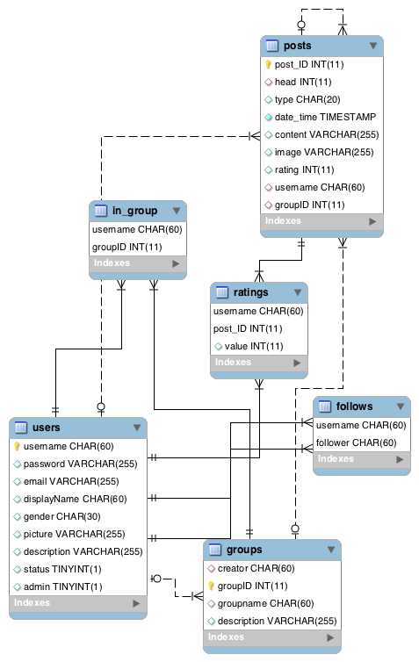

*Figure 1*: ER Diagram for Brainstorm's database